**Task 2 (P6)**

How Facebook works?

Facebook is a social networking site where you can communicate with your friends. First of all, the user needs to fill in the details that is required by this site. Firstly, you need to type the on the address bar, [www.facebook.com](http://www.facebook.com) . You will be required to have a suitable email address that works.



These are all the details you fill out

It’s completely free so the user don’t have to pay for anything

Once you signed up, every time you go on this site, it requires to enter your details. Without these, you can’t proceed.



Furthermore once you have completed the registration, this will appear up.

You can search any of your friends and add them. Once added, you can communicate with them.

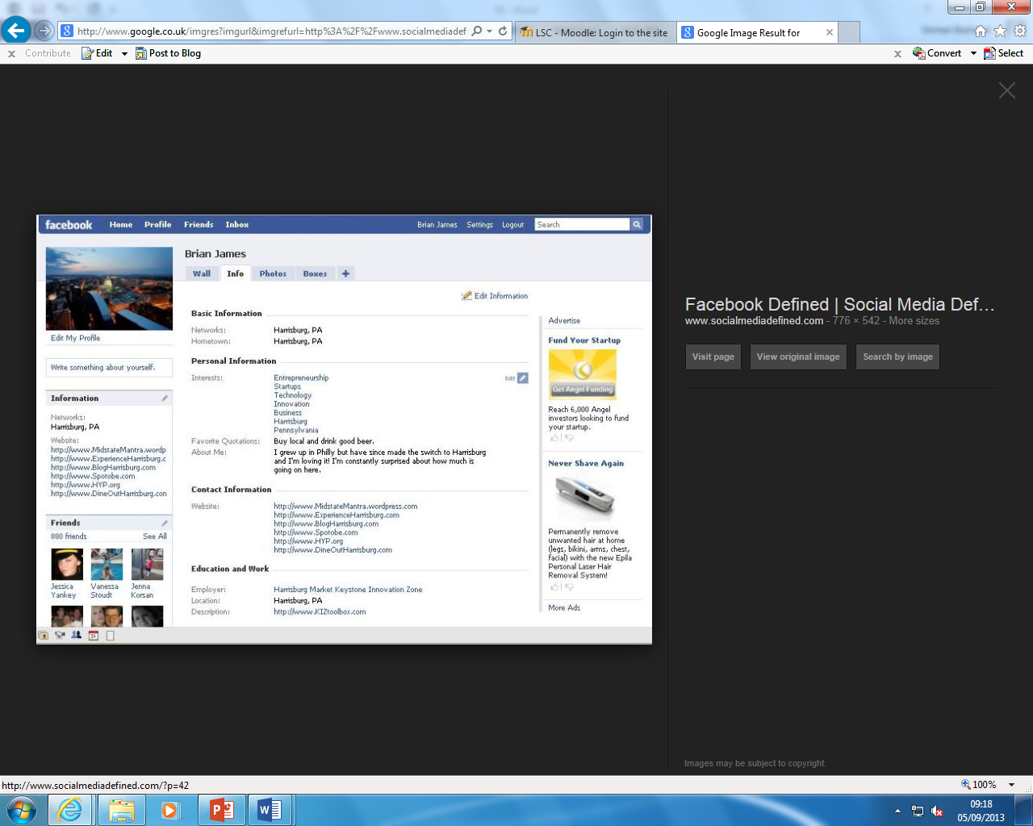

These are all the details that all the user’s friends are going to be visualising.

This illustrates all your friends and family.

[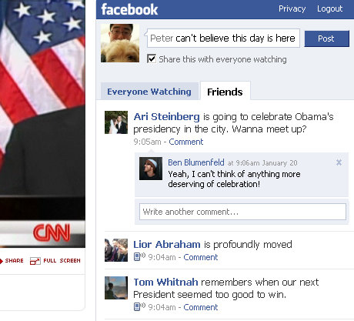](http://www.google.co.uk/url?sa=i&rct=j&q=&esrc=s&frm=1&source=images&cd=&cad=rja&docid=46AG8XRSxZZVlM&tbnid=3AsSd9Pz-JbkGM:&ved=0CAUQjRw&url=http://www.facebook.com/blog/blog.php?blog_id=company&m=1&y=2009&ei=VUUoUoq5GsjG7AbfvICoCg&bvm=bv.51773540,d.ZGU&psig=AFQjCNFEowGSaA7Hok60aqhqJSKFifIr9A&ust=1378457289640716)Once the user’s details is updated, then you can talk to people by putting statuses up on the person’s wall. Other people can see these statuses; when you put that status up, what date you put it up and other friends can comment on it to see what they think of it.

[](http://www.google.co.uk/url?sa=i&rct=j&q=&esrc=s&frm=1&source=images&cd=&cad=rja&docid=zBICSkjz-xF8uM&tbnid=kYpU-_xmb_xX6M:&ved=0CAUQjRw&url=http://computer.howstuffworks.com/internet/tips/how-to-upload-photos-on-facebook.htm&ei=VUYoUsXCNYTA7AaF6oGICA&bvm=bv.51773540,d.ZGU&psig=AFQjCNFiMHKInsjGrs0O6ON9MCmryc3G9Q&ust=1378457550755928)

You can also put pictures up of yourself. It’s different on a mobile phone on how to put it up, but it’s the same procedure.

As you can see on the screen shot, the navigation bar has many options for the user to do. Many communications are provided here.

By clicking this next to your friends profile page, you can add them. Once they have accepted, you can communicate with them.

[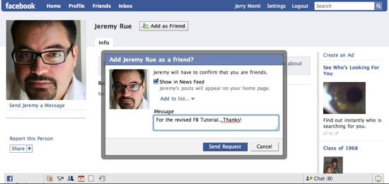](http://www.google.co.uk/url?sa=i&rct=j&q=facebook%20add%20friend&source=images&cd=&cad=rja&docid=pNRWcGIqw9VSWM&tbnid=Nwt5hrPZz_MzpM:&ved=0CAUQjRw&url=http://multimedia.journalism.berkeley.edu/tutorials/facebook-journalists/facebook-friends/&ei=40IoUveaHoayhAfbs4GgCA&psig=AFQjCNEpJYOC99NiIN6yREgiwiUe_9TKow&ust=1378456666663250)

[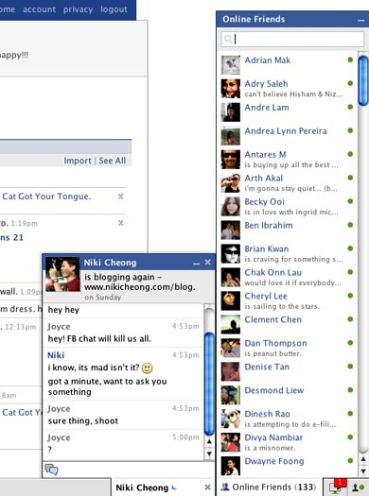](http://www.google.co.uk/url?sa=i&rct=j&q=facebook+chat+example&source=images&cd=&cad=rja&docid=bgZDlLKSS5HVkM&tbnid=A0uf9ofE2pTA7M:&ved=0CAUQjRw&url=http://deltontaylor.wordpress.com/2010/02/07/a-identity-lost/&ei=l2QoUua5FKPD7AaJjoHwBg&bvm=bv.51773540,d.ZGU&psig=AFQjCNG8J5M4QF9MvfYk_TB3V2o5nYxvXw&ust=1378465292336986)

[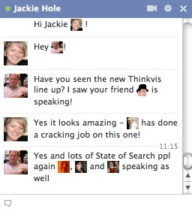](http://www.google.co.uk/url?sa=i&rct=j&q=facebook+chat+example&source=images&cd=&cad=rja&docid=MkDGTjuI1okYDM&tbnid=fIz9zpGa0e3ANM:&ved=0CAUQjRw&url=http://www.stateofsearch.com/how-well-do-you-know-your-friends-facebook-chat-function-will-show-you-and-facebook/&ei=NmUoUqTEM6qg7Ab-1YCYDQ&bvm=bv.51773540,d.ZGU&psig=AFQjCNG8J5M4QF9MvfYk_TB3V2o5nYxvXw&ust=1378465292336986)This is the ‘Online Friends’ list where you can browse up one of your friends and communicate with them.

Here is an example of how people communicate with each other. They type these sentences, by using the keys on the keyboard.

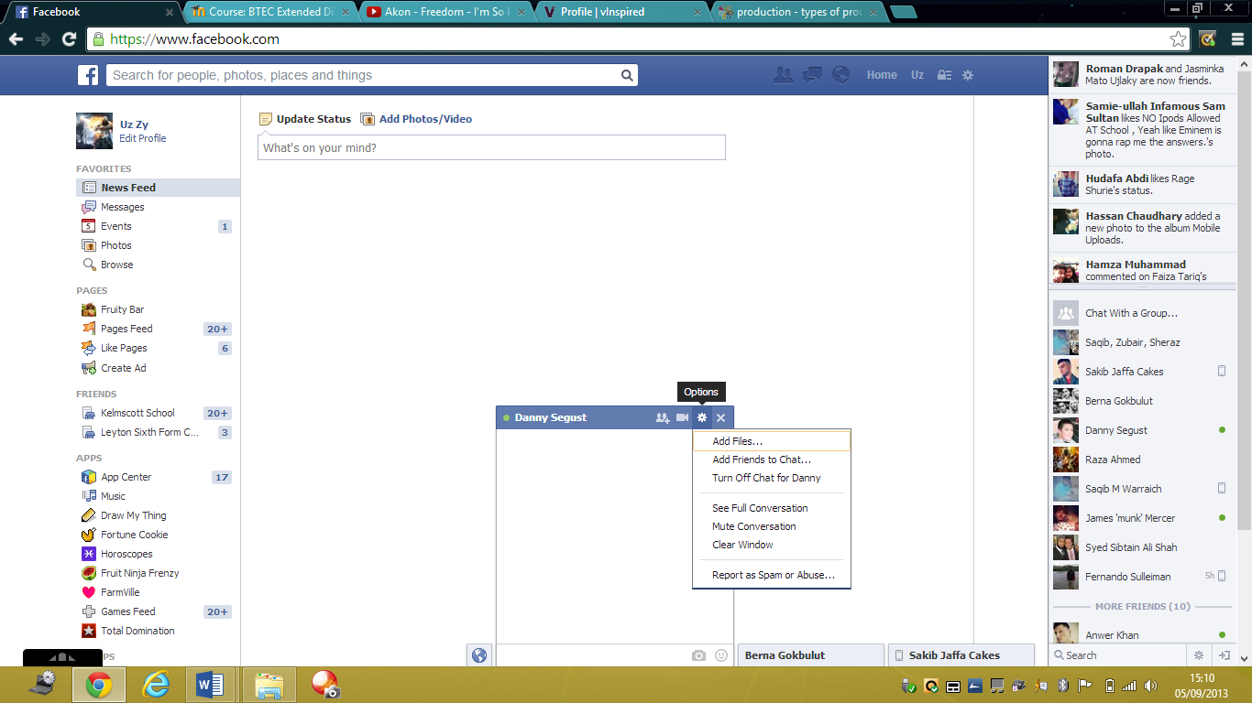 These options can be found in the top-right corner of a chat. They are several options if you want to send pictures, files. However, if you do not want to talk to the person, you can turn the chat off for that particular person. Also, you can report him.

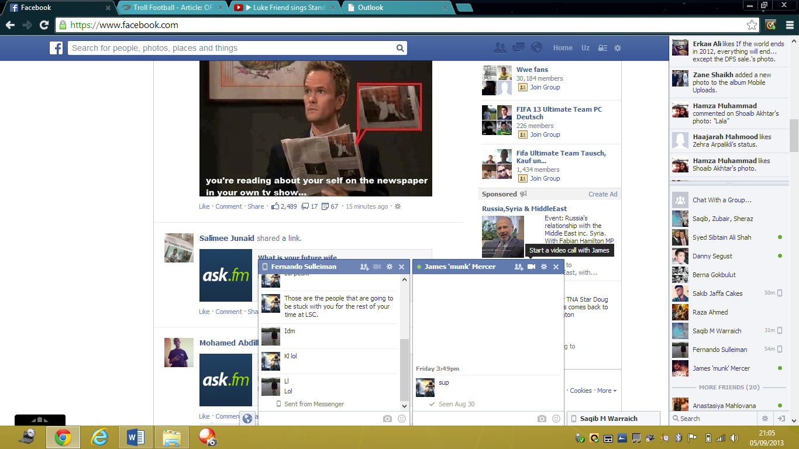This is an example of how to communicate through verbally, just by clicking the button, shown on the screenshot. However, you will need a webcam, both people, to communicate verbally.